3.7: a)
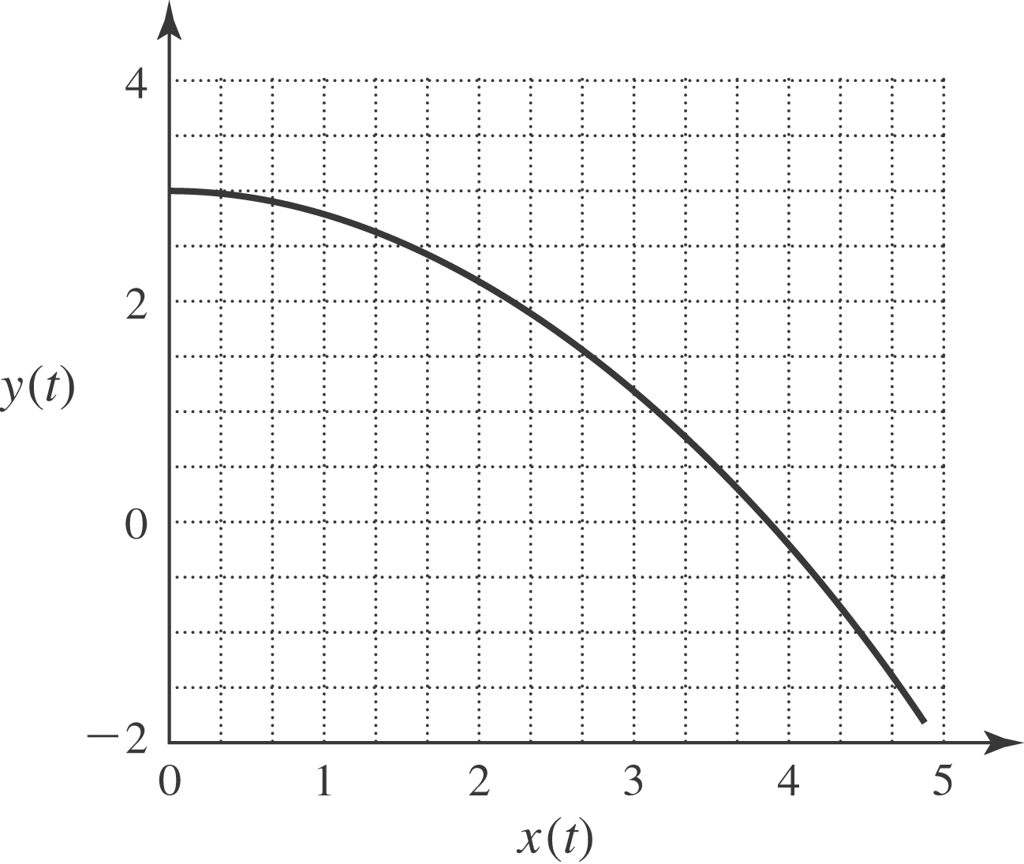

b)
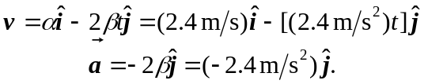
c) At 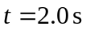, the velocity is 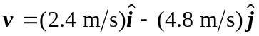; the magnitude is 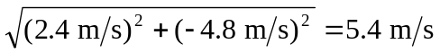, and the direction is 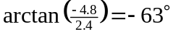. The acceleration is constant, with magnitude 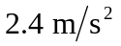 in the 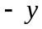-direction. d) The velocity vector has a component parallel to the acceleration, so the bird is speeding up. The bird is turning toward the -direction, which would be to the bird’s right (taking the -direction to be vertical).

